LAB 11
Spring 2011, BESE 15
Design Patterns

Objective:
The aim of this lab is to introduce students to the concept design patterns.

Submission:
During lab timings.

Background:
In software engineering, a design pattern is a general repeatable solution to a commonly occurring problem in software design. A design pattern isn't a finished design that can be transformed directly into code. It is a description or template for how to solve a problem that can be used in many different situations.

Uses of Design Patterns:
Design patterns can speed up the development process by providing tested, proven development paradigms. Effective software design requires considering issues that may not become visible until later in the implementation. Reusing design patterns helps to prevent subtle issues that can cause major problems and improves code readability for coders and architects familiar with the patterns.

Creational design patterns
This design patterns is all about class instantiation. This pattern can be further divided into class-creation patterns and object-creational patterns. While class-creation patterns use inheritance effectively in the instantiation process, object-creation patterns use delegation effectively to get the job done.

- Abstract Factory
Creates an instance of several families of classes
- Builder
Separates object construction from its representation
- Factory Method
Creates an instance of several derived classes
- Object Pool
Avoid expensive acquisition and release of resources by recycling objects that are no longer in use
- Prototype
A fully initialized instance to be copied or cloned
- Singleton
A class of which only a single instance can exist

Structural design patterns
This design patterns is all about Class and Object composition. Structural class-creation patterns use inheritance to compose interfaces. Structural object-patterns define ways to compose objects to obtain new functionality.

- Adapter
Match interfaces of different classes
- Bridge
Separates an object’s interface from its implementation
- Composite
A tree structure of simple and composite objects
- Decorator
Add responsibilities to objects dynamically
- Facade
A single class that represents an entire subsystem
- Flyweight
A fine-grained instance used for efficient sharing
- Private Class Data
Restricts accessor/mutator access
- Proxy
An object representing another object

Behavioral design patterns
This design patterns is all about Class's objects communication. Behavioral patterns are those patterns that are most specifically concerned with communication between objects.

- Chain of responsibility
A way of passing a request between a chain of objects
- Command
Encapsulate a command request as an object
- Interpreter
A way to include language elements in a program
- Iterator
Sequentially access the elements of a collection
- Mediator
Defines simplified communication between classes
- Memento
Capture and restore an object's internal state
- Null Object
Designed to act as a default value of an object
- Observer
A way of notifying change to a number of classes
- State
Alter an object's behavior when its state changes
- Strategy
Encapsulates an algorithm inside a class
- Template method
Defer the exact steps of an algorithm to a subclass
- Visitor
Defines a new operation to a class without change

Facade Pattern
Make a complex system simpler by providing a unified or general interface, which is a higher layer to these subsystems.

Benefits of Facade Pattern
- To reduce complexities of a system.
- Decouple subsystems, reduce its dependency, and improve portability.
- Make an entry point to your subsystems.
- Minimize the communication and dependency between subsystems.
- Security and performance consideration.
- Shield clients from subsystem components.
- Simplify generosity to specification.
Structure:
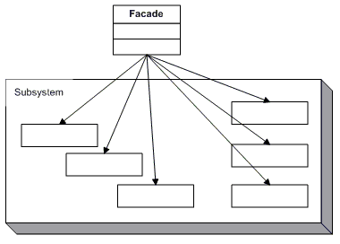

Task 1:
The classes and/or objects participating in this pattern are as given below. Create a class diagram to represent the classes as given. You can use any other application/example that you see fit for this design pattern.
- Facade (MortgageApplication)
  - knows which subsystem classes are responsible for a request.
  - delegates client requests to appropriate subsystem objects.
- Subsystem classes (Bank, Credit, Loan)
  - implement subsystem functionality.
  - handle work assigned by the Facade object.
  - have no knowledge of the facade and keep no reference to it.

Factory Pattern
Define an interface for creating an object, but let subclasses decide which class to instantiate. Factory Method lets a class defer instantiation to subclasses.

Structure:
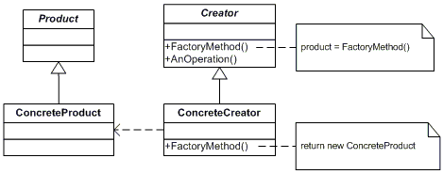
Task 2:
The classes and/or objects participating in this pattern are as given below. Create a class diagram to represent the classes as given. You can use any other application/example that you see fit for this design pattern.
- Product (Page)
  - defines the interface of objects the factory method creates
- ConcreteProduct (SkillsPage, EducationPage, ExperiencePage)
  - implements the Product interface
- Creator (Document)
  - declares the factory method, which returns an object of type Product. Creator may also define a default implementation of the factory method that returns a default ConcreteProduct object.
  - may call the factory method to create a Product object.
- ConcreteCreator (Report, Resume)
  - overrides the factory method to return an instance of a ConcreteProduct.

Singleton Pattern
Ensure a class has only one instance and provide a global point of access to it.

Structure:
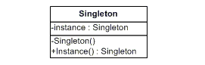

Task 3:
The classes and/or objects participating in this pattern are as given below. Create a class diagram to represent the classes as given. You can use any other application/example that you see fit for this design pattern.

- Singleton (LoadBalancer)
  - defines an Instance operation that lets clients access its unique instance. Instance is a class operation.
  - responsible for creating and maintaining its own unique instance.

Decorator Pattern
Attach additional responsibilities to an object dynamically. Decorators provide a flexible alternative to subclassing for extending functionality.

Structure:
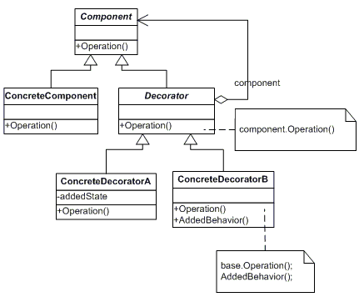

Task 4:
The classes and/or objects participating in this pattern are as given below. Create a class diagram to represent the classes as given. You can use any other application/example that you see fit for this design pattern.
- Component (LibraryItem)
  - defines the interface for objects that can have responsibilities added to them dynamically.
- ConcreteComponent (Book, Video)
  - defines an object to which additional responsibilities can be attached.
- Decorator (Decorator)
  - maintains a reference to a Component object and defines an interface that conforms to Component's interface.
- ConcreteDecorator (Borrowable)
  - adds responsibilities to the component.
Reference: http://www.dofactory.com/Patterns/Patterns.aspx

